**Use of array and continue and exit statement**

**THEORY:**

Array:

It is the fixed size sequence collection of elements of the same data type. It is simply the grouping of like data types. It can be used to represent list of numbers, or the list of names. There are three type of array among which we are going to use 1d array for this report.

Declaration:

Type variable_name[size];

Example:

Int rollno[10];

Continue:

It is the keyword that is used to send let the program to let the program loop again prematurely without letting lines to be executed below it. It is mostly used with for, while, and do…while loop.

Syntax:

For(;<condition1>; increment)

{

<statement>

If (<condition>)

Continue;

}

Exit:

The C library function void exit(int status) terminates the calling process immediately. Any open file descriptors belonging to the process are closed

Statement:

Void exit(int status);

1. **Program to print sum of first n number using continue.**

Algorithm:

Step1: start

Step2: enter the required nth number and store to a

Step3: i=1,x=0

Step4: while i<=a

X=x+i

If i!=a

Goto step4

Step5: print x

Step6: stop

Code:

#include<stdio.h>

int main()

{

int i,a,x=0;

printf("enter the number of n elements");

scanf("%d",&a);

for (i=1;i<=a;i++)

{

x=x+i;

if(i!=a)

{

continue;

}

printf("sum is %d",x);

}

}

Output:

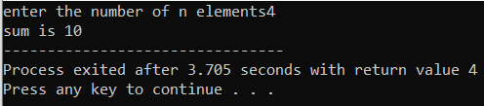

1. **Program to find the greatest number among the entered number.**

Algorithm:

Step1: start

Step2: enter numbers as per required

Step3: k=0

Step4: if a>k

K=a

Step5: print k

Step6: stop

Code:

#include <stdio.h>

# include <stdlib.h>

int main()

{

int a,k=0;

printf("enter numbers and end with zero to terminate\n");

scanf("%d",&a);

while (a!=0)

{

scanf("%d",&a);

if (a>k)

{

k=a;

}

}

printf("greatest entered number=%d",k);

return 0;

}

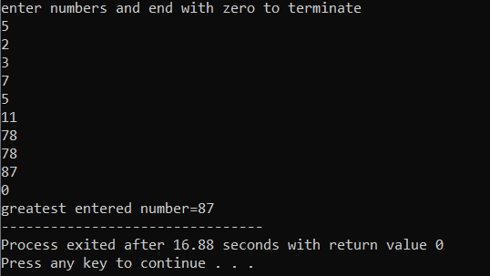Output:

1. **Program to illustrate the use of exit function.**

Algorithm:  
step1: start

Step2: i=1

Step3: until i!=6

A=a+i

If i==5

Display a

Exit

Step4: stop

Code:

#include<stdio.h>

int main()

{

int a=0;

int i=1;

for (i=1;i<=6;i++)

{

a=a+i;

if (i==5)

{

printf("sum= %d",a);

void exit();

}

}

return 0;

}

Output:

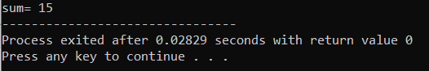

1. **Program to find the sum of odd index of the array.**

Algorithm:

Step1: start

Step2: make an array of integers and store it to a

Step3: i=0, s=0

Step4: while i<=9

If i%2!=0

S=s+a[i]

i++

step5: print s

step6: stop

Code:

#include<stdio.h>

int main()

{

int a[10]={1,5,2,3,5,3,1,6,7,12};

int i=0,s;

for (s=0;i<=9;i++)

{

if (i%2!=0)

s=s+a[i];

}

printf("sum= %d",s);

return 0;

}

Output:

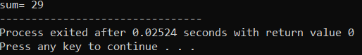

1. **C program to search an element in an array**

Algorithm:

Step1: start

Step2: enter number to search and store to j

Step3: for (i=1; i<=9;i++)

if j=f[i]

print i

k=0

if k!=0

print not found

Step4: stop

Code:

#include <stdio.h>

int main()

{

int f[10]={1,6,35,7,86,4,7,43,2,45};

int i,j,k=1;

printf("Enter the number to search\t");

scanf("%d",&j);

for (i=1; i<=9;i++)

{

if (j==f[i])

{

printf("%d is found on %d position",j,i);

k=0;

}

}

if (k!=0)

{

printf("%d is not found",j);

}

return 0;

}

Output:

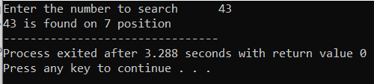

1. **C program to implement bubble sort.**

Algorithm:  
Step1: start

Step2: enter the number of required elements

Step3: enter the elements and store to array

Step4: for i=0;i<e;i++

for j=0;j<e;j++

if srt[j]<srt[j+1]

s=srt[j]

srt[j]=srt[j+1]

srt[j+1]=s

Step5: print elements of srt array

Step6: stop

Code:

#include <stdio.h>

int main()

{

int array[100], n, c, d, swap;

printf("Enter number of elements\n");

scanf("%d", &n);

printf("Enter %d integers\n", n);

for (c = 0; c < n; c++)

scanf("%d", &array[c]);

for (c = 0 ; c < n - 1; c++)

{

for (d = 0 ; d < n - c - 1; d++)

{

if (array[d] > array[d+1])

{

swap = array[d];

array[d] = array[d+1];

array[d+1] = swap;

}

}

}

printf("Sorted list in ascending order:\n");

for (c = 0; c < n; c++)

printf("%d\n", array[c]);

return 0;

}

Output:

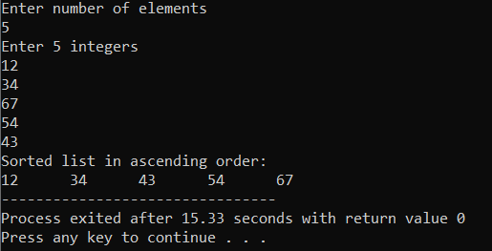

**Conclusion:**

From these series of problems we have learned various types of c program with various features. Some of them are continue, exit, and use of array for various types of problem solving.one of the major program we learned in this project is bubble sort which is one of the major way of sorting the numbers in ascending or descending order according to the requirement.